Template of Manuscript : Research Title
The names of the authors
The address of the institution
Corresponding author: The affiliation address, telephone number, fax and email address
Abstract
The abstract should be clear, descriptive and not longer than 300 words. References should be avoided. Non-standard or uncommon abbreviations should be avoided, but if essential they must be defined at their first mention in the abstract itself.
Keywords
A maximum of 5 keywords, (avoid, for example, 'and', 'of').
1. Introduction
The introduction starts following the abstract. The introduction briefly justifies the research and specifies the hypotheses to be tested. Extensive discussion of relevant literature should be included in the discussion of results, not in the introduction.
2. Materials and Methods
The statistical model, classes, blocks, and experimental unit must be designated. Any restrictions used in estimating parameters should be defined. Levels of statistical significance which can be mentioned without further explanation are *p< 0.05, **p< 0.01 and ***p< 0.001.
3. Results
Results should be presented in tabular form when feasible. The text should explain or elaborate on the tabular data, but numbers should not be repeated extensively within the text. Sufficient data, all with some index of variation attached, should be presented to allow the reader to interpret the results of the experiment.
4. Discussion
The discussion should interpret the results clearly and concisely and should integrate results of the literature survey with the research findings, to provide the reader with a broad base on which to accept or reject the hypotheses tested. Results and references to tables and figures already described in the Results section should not be repeated in the Discussion section.
5. Conclusion
This section, consisting of no more than 300 words, follows the discussion and should explain in lay terms, without abbreviations, acronyms, or citations, what the findings of this research imply for that field.
6. Conflict of Interest
We certify that there is no conflict of interest with any financial organization regarding the material discussed in the manuscript.
7. Acknowledgments (Optional)
You are requested to identify who provided financial support (if, any).
8. References
Lestrelin, G., Vigiak, O., Pelletreau, A., Keohavong, B. and Valentin, C. (2012). Challenging established narratives on soil erosion and shifting cultivation in Laos. Natural Resources Forum, 36: 63–75.
Table 1. The name of this table one
Items | T1 | T2 | T3 | SEM | P-value
………......... | ….. | ….. | ….. | ….. | ……..
………......... | ….. | ….. | ….. | ….. | ……..
………......... | ….. | ….. | ….. | ….. | ……..
………......... | ….. | ….. | ….. | ….. | ……..
………......... | ….. | ….. | ….. | ….. | ……..
SEM: Standard Error of Means.

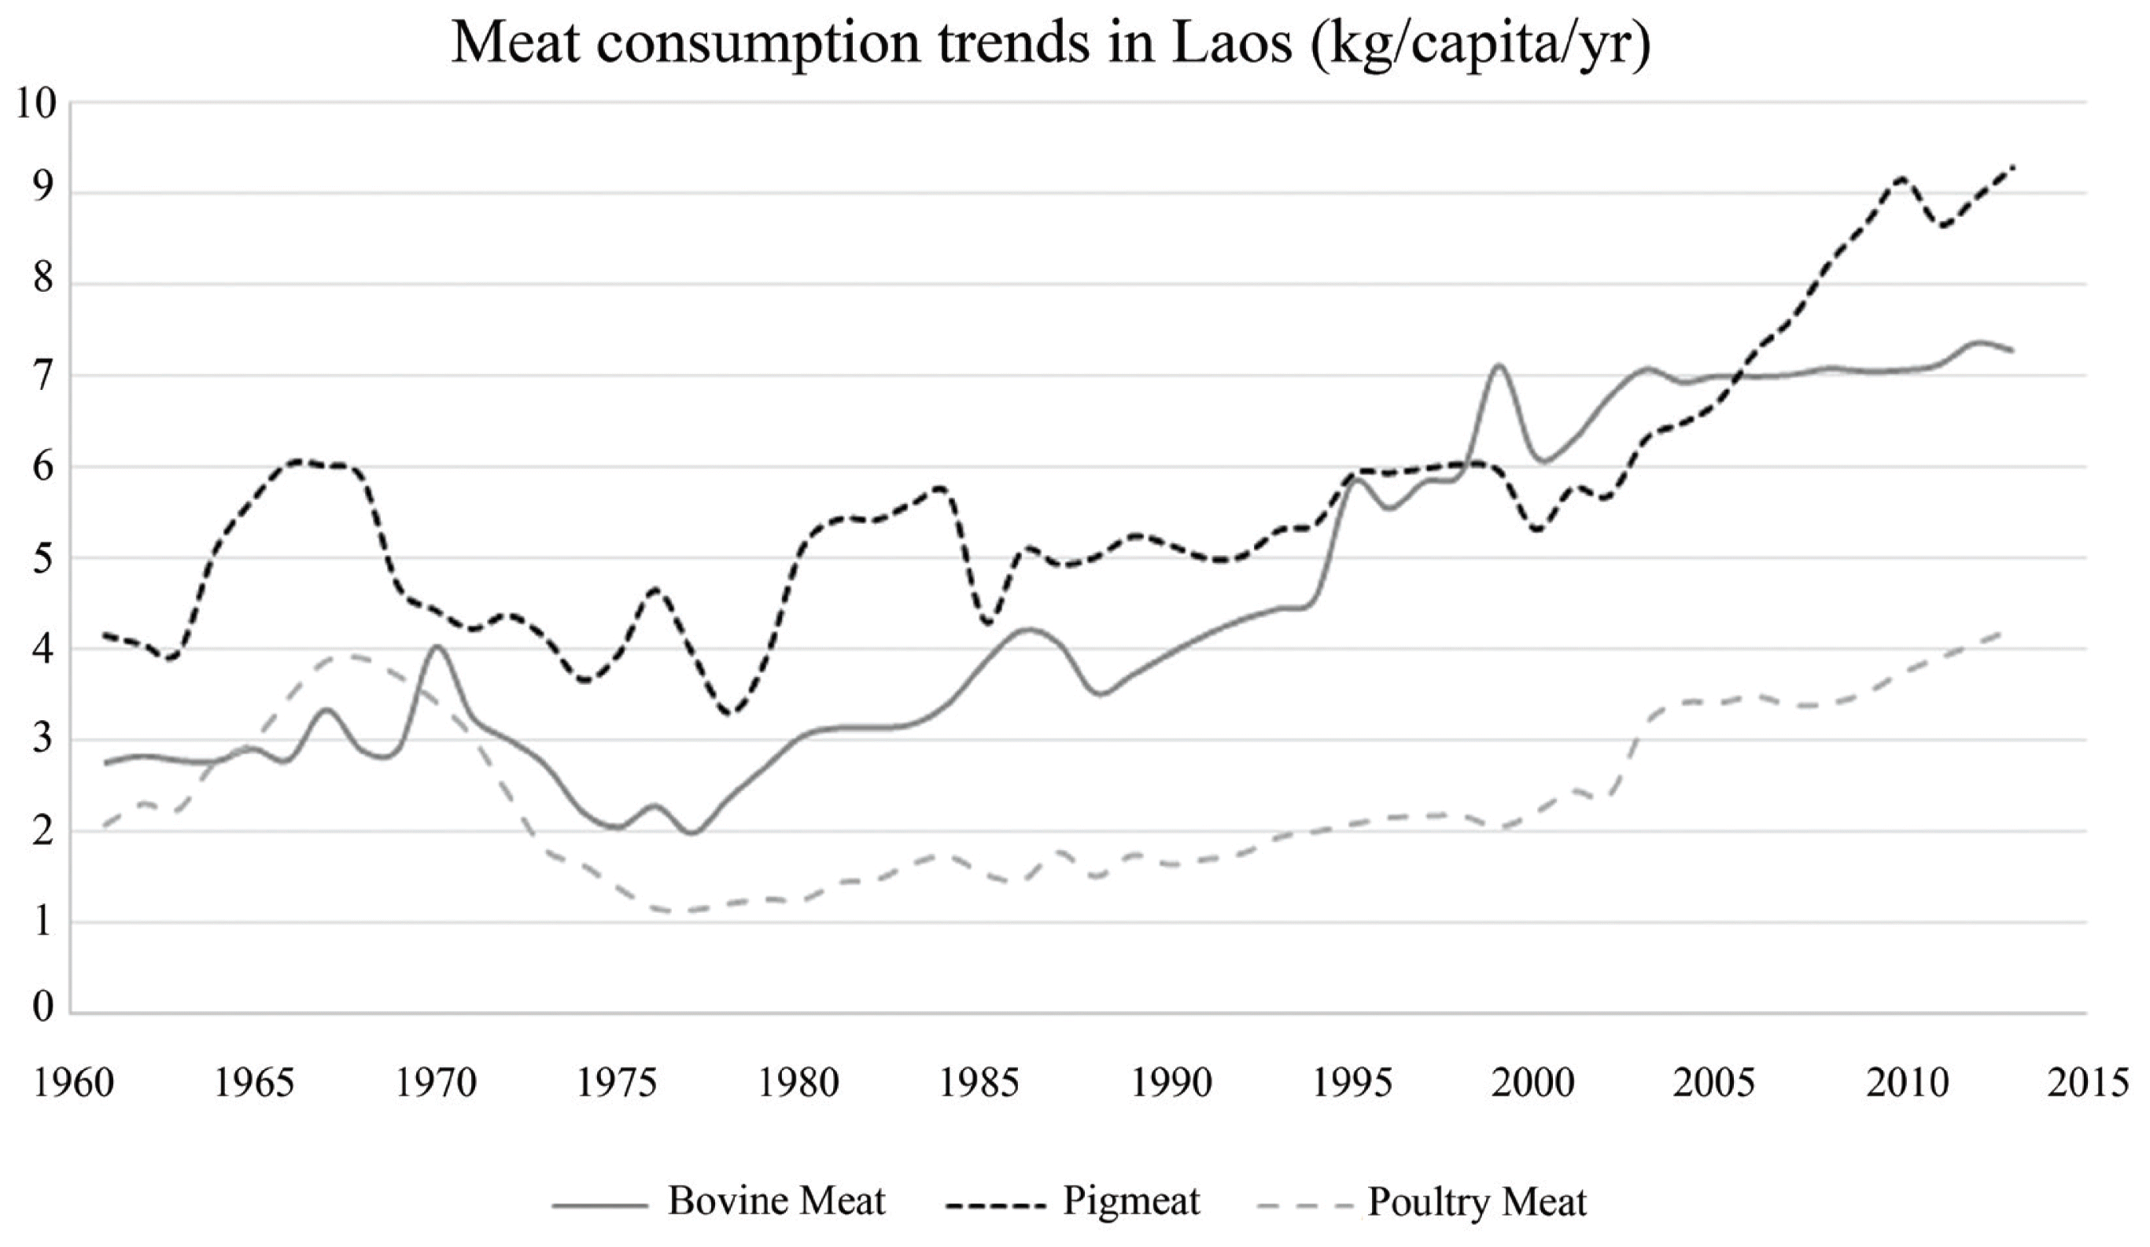
Figure 1. The name of figure one

